Intelligent water distribution system

By Team Members:

1.Uday Vardan Atti (18481a1213)

2.Meghana Guttikonda (18481A1236)

3.Jonnalagadda M.V.D Sai Srinivas (18481A1238)

4.Kaladindi Anand Kumar (18481A1239)

5.Myna Kodali (18481a1246)

the prerequsites:

\*Python IDLE

\*IBM account

\*Features

\*Advantages and Disadvantages

\*Node-red Application

\*IBM Whatson IOT platform

\*Fast to sms

ABSTRACTION:

The Water is an significant resource for individual human and its existence. Nowadays,

the population in cities are increasing rapidly, due to certain amount of people migration

from a rural area to urban areas. To meet the need of water requirement, its distribution and

quality check, a novel approach is proposed which is based on IoT (Internet of Things).

The proposed system consists of different sensors like water flow sensor, pH Sensor, water

control valve, and a microcontroller. A water control valve is controlled through web interface

based on water flow sensor value to ensure equal and adequate water distribution to each

connection (end point). The pH sensor is used to measure the quality of the water.

The pressure sensor is used to measure the water flow pressure and the leakage detection in

pipe is also measured. The distribution of water and management of water flow through

the pipe can be controlled in this paper.

INTRODUCTION:

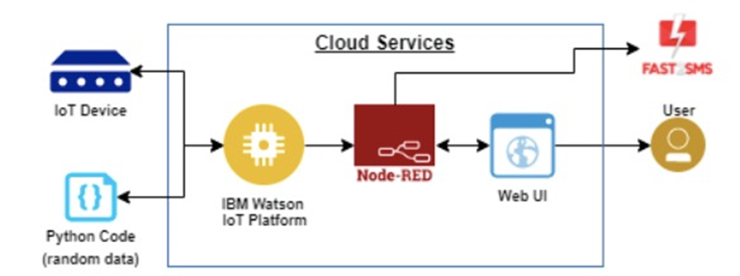

According to recent survey, water has become a big issue because of less rain fall, increase in population many cities

are facing this problem people have to suffer from this problem they don’t have sufficient amount for their daily

needs. Due to lack of monitoring water can’t be supplied properly, some areas in city get water while other some

areas can’t so, there is a need of continuous monitoring, water supply scheduling and proper distribution another

problems are excessive consumption, overflow of tanks, leakage in pipeline, interrupted water supply. Water is a

basic need of every human being everyone has to save the water many times with lack of monitoring, overflow of these

overhead tanks can occur because of this lots of water get wasted, another thing because of overflow in the pipelines

with more pressure there is possibility of pipeline damage, leakage detection is one more problem all these problems

are because of lack of monitoring, manual work, less man power. Before implementing this project I have taken a

survey of Bangalore city to understand water supply distribution and related problems with the system, after

taking a survey I observe that all the work is manual and need a better technology to make proper distribution. By

focusing on problems in traditional methods our system design and develop a low cost embedded system device for

real time monitoring of water distribution system in Internet of things (IOT) platform.

IOT is a world where billions of objects can sense, communicate and share information , all interconnected over

public or private Internet Protocol (IP) networks. These interconnected objects have data regularly collected,

analysed and used to initiate action, providing a wealth of intelligence for planning, management and decision making.

The Internet Of Things (IOT) is the inter-networking of physical devices, vehicles (also referred to as "connected

devices" and "smart devices"), buildings, and other items embedded with electronics, software, sensors, actuators,

devices many more and network connectivity which enable these objects to collect and exchange data. In 2013 the Global

Standards Initiative on Internet of Things (IOT-GSI) defined the IOT as "a global infrastructure for the information

society, enabling advanced services by interconnecting (physical and virtual) things based on existing and evolving

interoperable information and communication technologies" and for these purposes a "thing" is "an object of the physical

world (physical things) or the information world (virtual things), which is capable of being identified and integrated

into communication networks". The IOT allows objects to be sensed or controlled remotely across existing network

infrastructure, creating opportunities for more direct integration of the physical world into computer-based

systems, and resulting in improved efficiency, accuracy and economic benefit in addition to reduced human intervention.

When IOT is augmented with sensors and actuators, the technology becomes an instance of the more general class of

cyber-physical systems, which also encompasses technologies such as smart grids, virtual power plants, smart

homes, intelligent transportation and smart cities. Each thingis uniquely identifiable through its embedded computing

system but is able to interoperate within the existing Internet infrastructure. Experts estimate that the IOT will

consist of about 30 billion objects by 2020. These devices collect useful data with the help of various existing

technologies and then autonomously flow the data between other devices. Current market examples include home

automation (also known as smart home devices) such as the control and automation of lighting, heating (like smart

thermostat), ventilation, air conditioning (HVAC) systems, and appliances such as washer/dryers, robotic vacuums, air

purifiers, ovens, or refrigerators/freezers that use Wi-Fi for remote monetoring

FEATURES:

Storage facilities, or distribution reservoirs, provide clean drinking water storage (after required water treatment process)

to ensure the system has enough water to service in fluctuating demands (service reservoirs), or to equalize the operating

pressure (balancing reservoirs). They can also be temporarily used to serve fire fighting demands during a power outage.

The following are types of distribution reservoirs:

Underground storage reservoir or covered finished water reservoir: Underground storage facility or large ground excavated

reservoir that is fully covered. The walls and the bottom of these reservoirs may be lined with impermeable materials to

prevent ground water intrusion.

Uncovered finished water reservoir: Large ground excavated reservoir that has adequate measures or lining to prevent

surface water runoff and ground water intrusion but it does not have a top cover. This type of reservoirs are less desirable

as the water will not be further treated before distribution but it is susceptible to contaminants such as bird waste,

animal and human activities, algal bloom, and airborne deposition.[10]

Surface reservoir (also known as ground storage tank and ground storage reservoir): Storage facility built on the ground

with the wall lined with concrete, shotcrete, asphalt, or membrane. Surface reservoir usually covered to prevent

contamination. They are typically located in high elevation areas that has enough hydraulic head for the distribution.

When a surface reservoir at the ground level cannot provide a sufficient hydraulic head to the distribution system,

booster pumps will be required.

Elevated water tank. A few common types are spheroid elevated storage tank, a steel spheroid tank on top of a

small-diameter steel column; composite elevated storage tank, a steel tank on a large-diameter concrete column;

and hydropillar elevated storage tanks, a steel tank on a large-diameter steel column. The space within the large column

below the water tank can be used for other purposes such as multi-story office space and storage space. A main concerns

for using water towers in the water distribution system is the aesthetic of the area.

Standpipe: A water tank that is a combination of ground storage tank and water tower water. It is slightly different from

an elevated water tower in that the standpipe allows water storage from the ground level to the top of the tank.

The bottom storage area is called supporting storage, and the upper part which would be at the similar height of an

elevated water tower is called useful storage.

Sump: This is a contingency water storage facility that is not used to distribute water directly. It is typically built

underground in a circular shape with a dome top above ground. The water from a sump will be pumped to a service

reservoir when it is needed.

Advantages:

Smart meters have already become an essential component of the modern-day electrical grids and are now

finding their way in the water utilities. Currently, in a world where people are perishing due to lack

of water, these meters are the breakthrough innovation that water utilities can use to provide everyone

with potable water.

Unlike traditional water gauges, smart water meters are a part of a wide area network that allow

utilities and consumers to engage in two-way communication. These meters help water suppliers to

enhance their water distribution network and incorporate robust water conservation & management

practices.

In the operational, industrial and consumer vertical, these meters offer numerous benefits.

Let us go through some of these advantages:

1) Dynamic Water Billing:

As we discussed, these smart water meters with IoT supports a two-way interaction between water

distributors and end consumers. This means that the water supplier can monitor the consumption of

individual houses that are connected to its network in real-time. Hence, the need for sending a person

to take onsite meter readings every month for billing end consumers is eliminated.

Based on the amount of water that a house uses every day, the IoT system can automatically calculate

the bill and send it to the consumers each month. This dynamic billing help utilities reduce operational

complexity and cut costs associated with manual billing procedures.

2) Rationing Water Consumption:

Modern-day IoT water flow meters are now embedded with a valve that can be controlled remotely.

This valve enable users (generally factories and plants) to regulate the flow of water and manage

their water consumption in order to optimize their operational processes while saving costs.

Normally, water consumption is rationed on the basis of:

Consumption thresholds:

Water rationing via consumption monitoring is used to reduce overflow conditions.

While filling tanks or cisterns, it is essential to keep an eye on the water level to avoid overfills

and water wastage. To automate these processes, consumption thresholds (based on tank capacities) can

be calibrated and programmed to cut the water supply through valves after a particular time interval.

This rationing is also very useful during droughts when water is scarce. In 2018, the city of Cape

Town in South Africa extended its days with running tap water by three to four months by limiting

every person's water needs by 50 liters per day. This may seem an unfair practice, but it really

helps in conserving drinkable water. The remote valve control system in smart water meters can hence

be used to preserve and manage water in harsh weather.

Time of use:

Limiting outdoor watering and irrigation in afternoon hours is the primary example of controlling

water flow based on time of use. To regulate the temperature of the soil in summers and maintain

their lush green gardens, many consumers keep their sprinklers unnecessarily on throughout the day.

By using remote valve control, the consumption of water can be limited to irrigate lawns as per requirement

and hence water can be preserved.

3.Monitoring of water quality:

The above-mentioned challenges make the manual method of measuring water quality quite redundant.

Smart water quality monitoring system using IoT are hence required to automatically monitor various

parameters that determine the quality of water.

Internet of Things has enabled the development of automatic water quality monitoring systems that

mitigate the above-mentioned challenges. By using devices like sensors and probes, several parameters

of water can be measured in real-time from remote locations.

These devices share live data about the quality of a water body to a platform suite. By using this

platform, a person or a company can take useful actions to ensure optimum water quality. Some variables

that can be measured through remote water quality monitoring devices.

4.Detection of leakages:

IoT-based water leakage detection system have the potential to manage data smartly.

Predictive analytics is one of the most chief features of IoT water leakage detecting solution

in which smart algorithms are used to analyze the condition of leaking zones.

Multiple sensor integration in IoT water leakage detector is the feature that helps to

identify both spot and zone leaks in the area.

IoT grounded leakage detection system is very flexible and scalable in nature.

Applications and dashboards are used along with IoT devices for data visualization and to get

alerts about leakage detection.

NODE-RED APPLICATION:

How to create node - red application:

1.Find the Node-RED Starter in the IBM Cloud catalog.

Log in to IBM Cloud. Open the catalog and search for node-red. Click on the Node-RED App tile. ...

2.Create your application. Now you need to create the Node-RED Starter application.

On the Create tab, a randomly generated App name will be suggested.

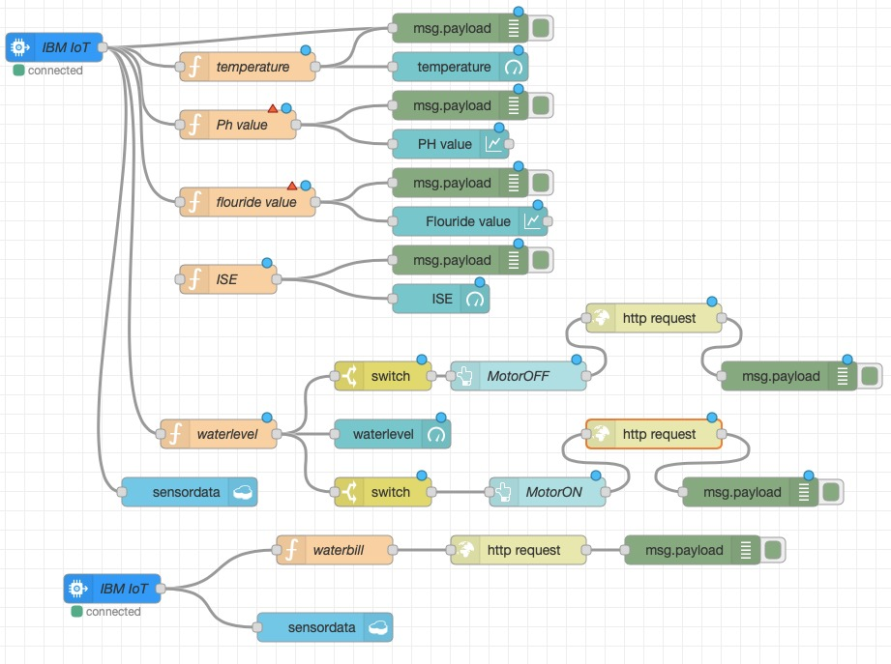

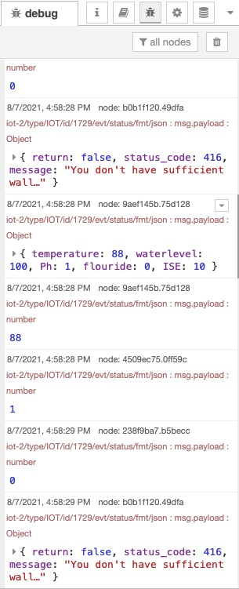

3.Enable the Continuous Delivery feature. At this point, you have created the application and

the resources it requires, but you have not deployed it anywhere to run.

4.Open the Node-RED application. Now that you’ve deployed your Node-RED application,

let’s open it up! ...

5.Configure your Node-RED application. The first time you open your Node-RED app,

you’ll need to configure it and set up security. ...

6.Add extra nodes to your Node-RED palette. Node-RED provides the palette manager

feature that allows you to install additional nodes directly from the browser-based editor.

The IBM IOT node is used for accessing data from the ibm cloud function node:

In our project we have used temperature, PH value, flouride value,ISE(ammonia,nitrate,chloride)node,

water level function nodes.Temperature function node is used as to get the temperature value of water

and phThere are 3 simulated sensors:

• Object temperature

• Temperature

• Humidity

The simulator (from IBM Cloud IoT Quickstart) connects automatically and starts

publishing data.

It must remain connected to visualize the data.

Use the simulator buttons to change the simulated sensor readings. Data is published

periodically.

3. Identify your virtual device ID (top right corner) :

copy it. You will use it in next sectio value function node is used for getting the ph value of

water and flouride value function node is used to get flouride value of water and the ISE function

node is used forgetting the ammonia,nitrate and chloride value.

Go back to Node-RED window

4. From left panel, drag and drop nodes to the workspace

• Chose the Input node ibmiot

• Add an output debug node

• Link them

5. Configure IBM IoT by double clicking on it

Click Done & deploy your flow by clicking the Deploy button (top right).

6. Check the Debug Panel on the right side while you are playing with the sensor

simulator. You should receive Device (sensor = web app. you opened in other window)data as

the ibm iot node.

7. Delete the whole flow by selecting all the nodes & pressing the ‘Delete’ key.

8. Click on workspace to paste imported nodes

9. Fill in the Device ID field in the IBM IoT App In node.

Let’s insert the event data coming from the Device sensors in a Cloudant database!

Remember that you already have a Cloudant service deployed for Node-RED. You will use it to

store your data.

1. Add a Cloudant Node (Cloudant OUT node in the Storage Category) & link it to the

temp function node

­­­­­ 2. Configure it:

• Service : Cloudant service name bound to your Node.js runtime.

As Node.js is already bound to a Cloudant Service, the service name should appear in

the top drop-down list.

At this point, the Continuous Delivery pipeline will automatically run to build and deploy that

change into your application. If you view the Delivery Pipeline you can watch its progress.

The Build section shows you the last commit made (1) and the Deploy section shows the progress of

redeploying the application (2).

Once the Deploy stage completes, your application will have restarted and now have

the node-red-dashboard nodes preinstalled.

The water level function node is used to get the get the water levels of the water tank. The switch node is used for

conditions.suppose in ur project if the water tank gets full and the switch will get activated and motor will be turned

off and if the water tank gets empty the then the switch node will be activated and the motor will be turned on.

